

Associative File System Research
11.09.2019
─
Rethinking Technology
Memphis, TN

Overview

## Transcript below needs summarizing and integrating into the rest of this document.
Copied from the Vision page:
If someone wants to integrate this into the sections above, please do.

File-system
First, the file-system. When a person opens up their computer, they have to use programs, and they have to save their work onto disk in a file. As a result, they have to interact with the file-system directly. Every major file-system currently in use is based on the hierarchical model, in which files exist inside of a folder, and folders can be created inside of folders. In this system, each file exists in exactly one folder, so you cannot put a file in multiple folders without copying it. Likewise, each folder also exists in exactly one folder.

Categorizing your files into folders
When you create a folder, you group your files together by category or purpose, and then you add all related files to this folder. But there is a problem. When you have a file that you want to exist in different folders, copying the file creates a separate file on disk, so now you have to manually keep these two files synchronized, which is tedious and wastes time.

Using shortcuts to put files into multiple folders
There are tools in Windows and MacOS that let you explicitly include a file into a different folder. These tools can create a new file, called a “shortcut” or “symbolic link”, in the secondary location, and this file contains a written-down reference to your original file in the original location. When you move the original file, the shortcut no longer works, because the shortcut does not keep track of the file. This causes problems, because shortcuts often cannot be opened by programs, due to an invalid target, as well as due to the shortcut file itself being perceived as the desired file, rather than its target. Shortcuts are also subject to a problem that only happens when you use the same disk on different computers, such as with a USB drive, going between home and work. In Windows, the disk drive is assigned a drive letter like F: or G: based on what letter is available, so if the drive letter you had when creating your links is already used when you move to a new computer, the shortcut will point to the wrong drive! If you unplug your device and plug it in the same computer later, and you have plugged in another drive before replugging the removable drive, the old drive letter might be unavailable. If the drive you set up in between uses is an important drive that you intend to keep plugged in, you’ll have to choose which drive to go back and remake the links on. On a similar note, if you reinstall a Windows operating system, any drive letter that you had manually set previously is forgotten, so the drive will be automatically given a new drive letter. When links are broken from any of these problems, you must manually recreate each one individually, or rectify the drive letter discrepancy. Because of all of these potential problems, shortcuts are not a portable solution, and anyone planning to use them has to think twice about any confusion they will cause in the future, so they are not useful long-term tools. Consequently, most people decide not to use them at all, if they are thinking ahead.

Is Linux better or worse?
In Linux, the shortcut feature is also available. Loading the same drive on different Linux computers often loads the drive in the same location, but this is not a guarantee. In addition to name changes, there are other problems with how the system loads drives, explained below, resulting in a bad interaction with shortcuts.

How Linux loads drives
When Linux loads a drive, it mounts the drive onto a folder (directory). By default, disks and other drives are loaded into their own unique folder within a dedicated folder for drives. Unlike Windows, where devices letters and navigating to another drive requires using a special command to change drive, Linux’s folder structure is global, so the entire system shares the same structure.
How does Linux determine what to name the folder for a drive? Each disk’s name is already stored in the metadata on the disk, so Linux copies the name from the metadata. So, for example, “My disk” gets loaded in /mnt/My disk , or “Cool Tunes USB” gets loaded in /media/Cool Tunes USB. The folder that houses the mount points is determined by the Linux distribution (i.e. “distro”, the brand or variety of Linux), and there may be different folders depending on which application loads the device (e.g. the system mounter in /mnt vs the user’s file manager in /media). Many Linux distributions use the same conventions, but this is not a guarantee (Zorin OS is notorious), as the developers make this decision based on preference. In addition, each file manager may have its own preference for where to load the drive.

Links in Linux
If you use a Linux system regularly, perhaps as a home system, you will inevitably want to register your external device with the system’s drive mounter. Because the mounter loads the drive into a different folder than the file manager, it breaks any links you may have made on the system that point to the drive. There is no system tool that automatically updates the references for you, so you have to do it yourself. A skilled programmer can add this feature to the operating system, but getting this approved by the groups that maintain the system projects is problematic.
On top of posing a problem on the same computer under different workflows, if you connect the drive to another computer where you don’t have the system mounter configured, all of the links you re-created as a system-mounted drive will be invalid. You might not be able to configure the new computer to mount the drive with the system mounter, if you don’t have those kind of administrative permissions, for example, if you are using a work-managed computer.
Lastly, what happens in Vegas, stays in Vegas, Linux and Windows shortcuts are not interchangeable. Using a Linux shortcut is impossible in Windows, and vice versa.

Drives don’t automatically load in Linux
As if the names changing wasn’t already enough of a problem, there are other problems in Linux. Drives are not automatically loaded when the computer starts up. However, apps will try to follow links to these drives. After a user loads the drive, these problems go away, but this may not help, when the program was trying to do something automatically for the system, like loading a database.
To restore the link’s functionality, users must manually load the drives using the file browser program every time they start the computer. If they want the drive to be loaded automatically, they must manually configure this, which requires an inordinate amount of knowledge about the system, including how to use the Linux command line, how to edit text files with admin access using the `sudo` or `sudoedit` command, how to edit text files from the command line using the `nano` command or a dozen other programs that have weird names, how to use the `mount` command to load a drive at a folder location, how to use the `man` command to read the manual for the `mount` command, and how to understand the configuration file and write a new entry, which is partly explained in the man pages and requires additional research online to use. Before they can do any of this, they have to understand how the system drive loader works. If the user is trying to load a drive that was formatted as Microsoft’s or Apple’s file-systems, then users have to figure out how to download and install a new file-system driver from their Linux brand’s official repository. Once they install the driver, they have to reboot their machine for the driver to be available, and there is nothing that informs them of this requirement. While there are ways to do this in a GUI, online instructions for how to do this invariably tell the user to “go use the command line” and give the user a command to run, without explaining what it does or why, or what kind of program is used to download, install, and update the program. Basically, it’s a pain in the ass. Needless to say, there are many problems with shortcuts and using external drives in Linux, and the solution is more painful than the problem, and it doesn’t solve all of the problems.

Problems using external drives with automated Linux systems
While loading a drive manually makes the problem go away, if the program was trying to automatically load something for the system or for other programs, having the drive automatically loaded by the system is required. This scenario happens often on unattended Linux computers, for example, website servers. If the system tries to load a program from an external drive that configures a program that is then loaded from the internal drive, this can result in the internal drive’s program running successfully with the wrong configuration, since it assumes that it should just make do without the data from the external drive and load its defaults. Loading the drive and manually re-running the program may be inappropriate, in this case. As it is, we don’t want to manually load or run things.

Loading drives from Windows and MacOS in Linux is difficult
The driver that allows Linux to load Microsoft NTFS drives is called `ntfs-3g` (NTFS, and APFS or HFS+, respectively), and the process alone of discovering this package is an extra step of research for users. Some Linux distros do not come with it pre-installed.
In order to load a drive automatically, the user must create a folder for it to be loaded in and then register the device with the system’s drive loader. The drive loader runs once during system startup and loads drives. New drives that connect after startup are not loaded automatically.
In order manually create a folder to load a drive.*** a file called “fstab” (file-system table) located in the “etc” folder, “/etc/fstab”. The system tools in Linux and the user-land are collectively referred to as the “GNU” user-land. GNU is actually not part of the Linux project, and is a separate project that frequently is used together with the Linux project. Linux is a “kernel. collectively referred to as the “GNU userland”. or via using the `mount` command. The Linux command line, called the terminal, requires detailed knowledge and understanding. is not for the faint of heart and for new users to use correctly.

Using hard-links
In Windows, modern copies of Windows use the NT file-system (NTFS), where NT stands for “New Technology”. In NTFS, you can link your files in a different way, using hard-links. A hard-link allows you to directly include a file in multiple folders at the same time, without making copies. This is very useful, but it is not available by default in Windows. In order to use this, the user must install tools to use on the command line, or install a set of tools
Hard-links are recorded directly into the file-system’s internal record of all the folders and files on the disk. This sort of table of contents or master list is called the “Master file table” or MFT.
NTFS is controlled by Microsoft, and if another system were to use it, they would have to pay Microsoft and follow Microsoft’s rules. They cannot modify the NTFS idea.
Contrary to its name, it is no longer new technology.

The New Stuff
These three system-level concepts have not changed in almost 50 years. The file-system structure of mainstream computers was first introduced in 1965. current concepts are system-level technologies that have shaped the way we use computers every day without anyone giving it a second thought.

New File-system
The associative database file-system will be directly responsible for improving the productivity of programmers, users, and maintainers (tech support). The associative file-system.
The GUI (graphical user interface) will be a much-needed upgrade from the existing paradigm of keyboard, mouse, and windows on the desktop. The concept of touch controls has been badly implemented on all desktop devices, so this is where we are starting.

Conflicts of interest on the file system
Examples where hierarchical model causes problems due to conflicts of interest on the file system.
GoLang assumes all code is in one folder dedicated to Go:
https://golang.org/doc/code.html#Workspaces
In reality, programmers mix different languages within the project and organize their code into project folders. They group their projects together in a “repos” (repositories) folder so they can find their projects quickly.

Introducing the Associative Data Model
To be continued…

Inter-Planetary File System (IPFS)
There is a project that is already implementing some aspects of the distributed hash-table / block-chain integration part of the file-system idea. It has some of the design aspects already worked out in the same way I had envisioned. For example, there is a way to treat highly-volatile files as mutable files while they are being modified and then change them to immutable files when they are finished.
What is IPFS? Inter-Planetary File System
https://docs.ipfs.io/introduction/overview/
Concepts:
https://docs.ipfs.io/guides/concepts/

File Permissions are a Nightmare

Examples
Deleting files requires permission from myself:
https://community.spiceworks.com/topic/2031630-deleting-files-that-require-permission-from-myself
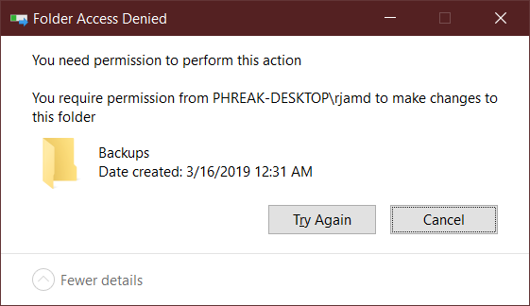
Changing the folder’s ownership to set it to the Administrators group does not respect the fact that I am an Administrator, either.
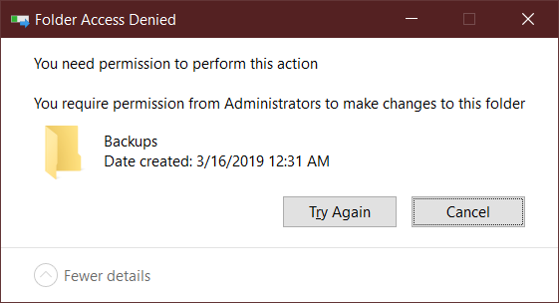
Changing the owner back to my user still fails, but changing the “Effective Access” user yields very peculiar OS behavior:
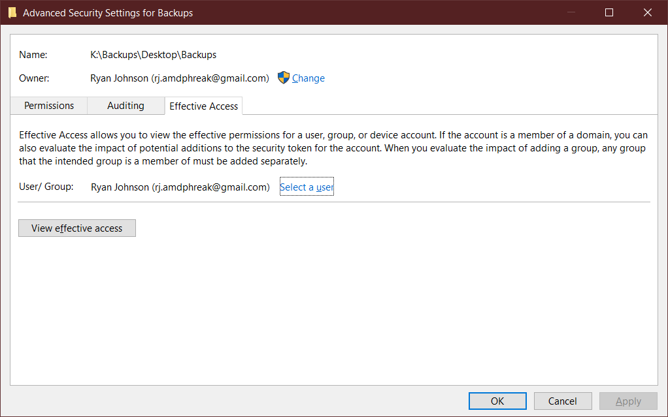
The OS both denies permission and requests permission to perform a deletion of the folder:
(This behavior was not reproducible so a screenshot was not acquirable.)

The suggestions from online to solve this problem involve giving yourself “Special Permissions”. But this is impossible, as the option is disabled:
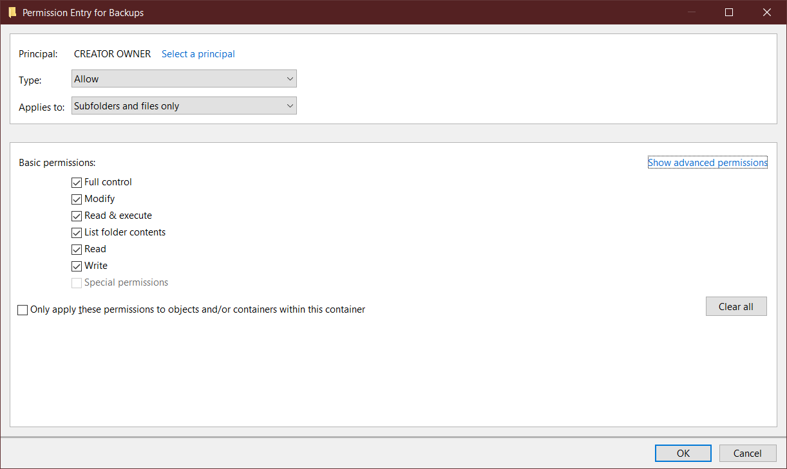

“Just reinstalled Windows Permissions on Secondary drive”:
https://answers.microsoft.com/en-us/windows/forum/windows_7-security/just-reinstalled-windows-permissions-on-secondary/df00a0fe-061a-43e9-92e0-5fcb11c191f4

Unexpected error keeping me from copying a file:
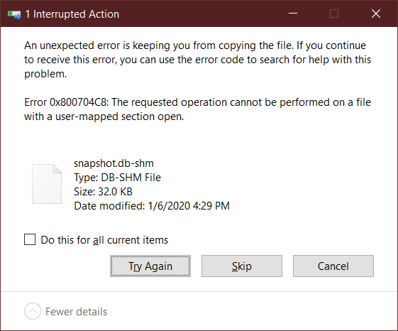
Closing all open applications and retrying did nothing.

Goals
- Lorem ipsum dolor sit amet, consectetuer adipiscing elit
- Sed diam nonummy nibh euismod tincidunt ut laoreet dolore magna aliquam erat volutpat.

Specifications
Nam liber tempor cum soluta nobis eleifend option congue nihil imperdiet doming id quod mazim placerat facer possim assum. Typi non habent claritatem insitam; est usus legentis in iis qui facit eorum claritatem. Investigationes demonstraverunt lectores legere me lius quod ii legunt saepius.

Lorem Ipsum
Duis autem vel eum iriure dolor in hendrerit in vulputate velit esse molestie consequat, vel illum dolore eu feugiat nulla facilisis at vero eros et accumsan.

Milestones

Lorem ipsum
Lorem ipsum dolor sit amet, consectetuer adipiscing elit, sed diam nonummy nibh euismod tincidunt ut laoreet dolore magna aliquam erat volutpat.

Dolor sit amet
Lorem ipsum dolor sit amet, consectetuer adipiscing elit, sed diam nonummy nibh euismod tincidunt ut laoreet dolore magna aliquam erat volutpat.

